- JSON is a lightweight data interchange format that is easy for humans to read and write, and easy for machines to parse and generate. It is primarily used to transmit data between a server and a web application, serving as a more compact and flexible alternative to XML  
- Need to import *json* module, use ‘’’ or “”” around data, and start/end with {}- data is represented as nested “lists’ or ‘dictionaries’ due to use of *key:value* pairs  
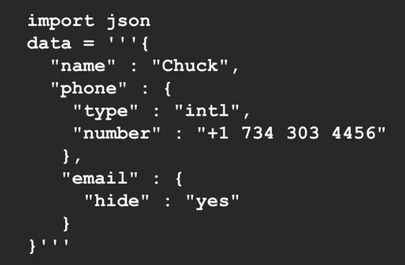 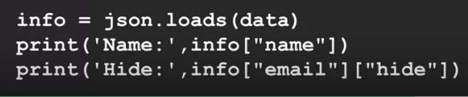

**Service Oriented Approach**  
  
- When your service pulls data (via JSON or XML) from other service providers to display to your users (Airline websites offering you car rentals/hotel rentals when you book flights)  
- This is done via ***API (Application Programming Interface)*** - a set of rules and protocols that allows different software applications to communicate with each other. It defines the methods and data formats that applications can use to request and exchange information. Enables developers to integrate different systems, applications, or services, allowing them to work together and share functionality.  
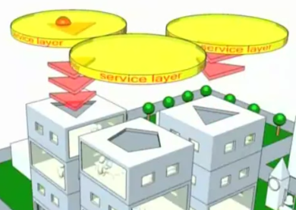

**GeoCoding API**

- [Geoapify.com](https://www.geoapify.com/)  
- Cloudflare performs “edge caching”. Once data is asked for once, it keeps a copy of that data in servers all over the world so when another user asks for that same data it is served from the Cloudflare server and not the actual data server (Below is data returned by web browser)  
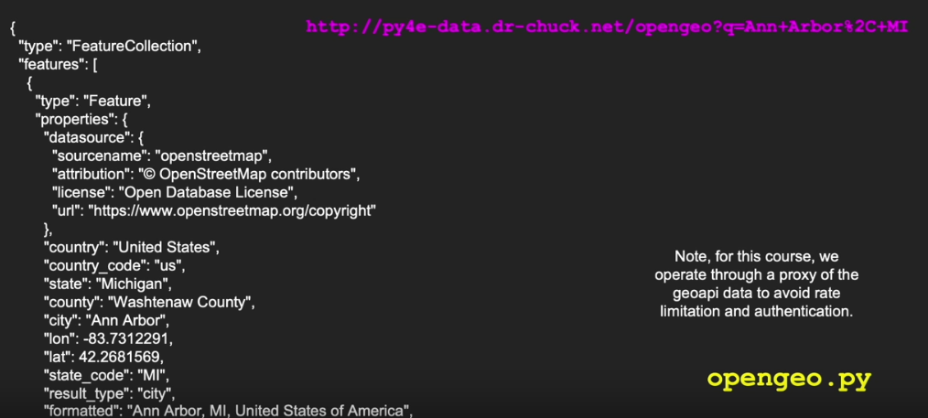

JSON version returned in Python  
- ‘q’ = address  
- url encoding - % = encoding for , and space  
